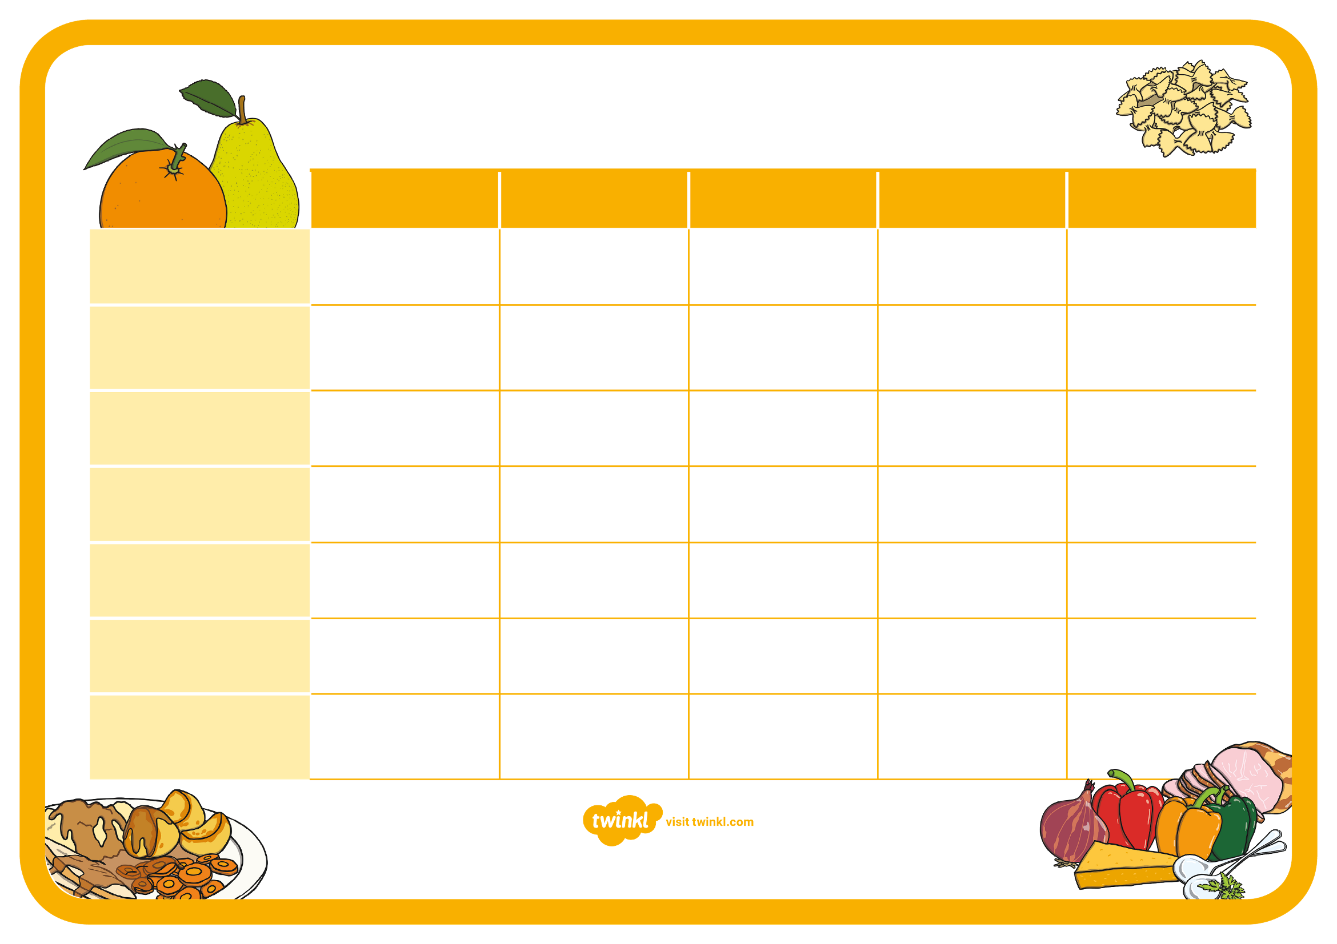

Filled roll & pom bears
Beans on toast
Burgers with veg sticks
Soup of the week & rolls
Pasta bake
Rice cakes & fruit yoghurt
Scones & strawberries
Cheese & crackers
Rich tea biscuits & Bananas
Pitta bread & peppers
Fresh fruit salad
Yoghurt
Melon medley
Satsumas
Jelly
Lentil Shepards pie & peas
Roast dinner & gravy
Mexican chicken & rice
Fish Pie & sweet corn
Sweet potato & chickpea curry
Breadsticks & Houmous
Oat cake & cucumber
Rice cakes & pears
Crackers & apple slices
Bagels & Bananas

Tea/Dinner

Afternoon Snack

Pudding
Lunch
Morning Snack
Friday
Wednesday
Thursday
Tuesday
Monday
Spring Menu week 3

